### Color Codes for Mechanical Systems ☑

Mechanical duct and pipe systems are independent of the duct and piping elements that are placed in a project to show the routing and connections between air terminals, mechanical equipment, or plumbing fixtures. Once air terminals and mechanical equipment are placed in a project, supply, return, exhaust and other air systems can be created to connect the components of the duct system. Once plumbing fixtures are placed in a project, domestic hot water, domestic cold water, sanitary and other piping systems can be created to connect the components of the plumbing system.

SFO uses eight duct system types and fifty-six piping system types customized to handle specific types of components and systems found at the airport. A list of duct and pipe system types can be found in the SFO Element Attribute Dictionary.

Setting up mechanical system View Filters and applying different color overrides is a two-step process. The first step is to establish the filter criteria for the different mechanical duct and piping systems. An example filter for a ‘Supply Air’ mechanical duct system is shown below. The filter is set up to look for duct-based categories that have a system type of ‘Supply Air’.

The second step in using View Filters to color mechanical systems is to apply a visibility override to the filtered elements. Once a filter has been created in the first step of the process, it can then be selected in the filter tab of a View Template. A color override can be applied to the line style for each mechanical system filter. Once the View Template is applied to a view, the ductwork or piping will be colored according to the color overrides for each filter.

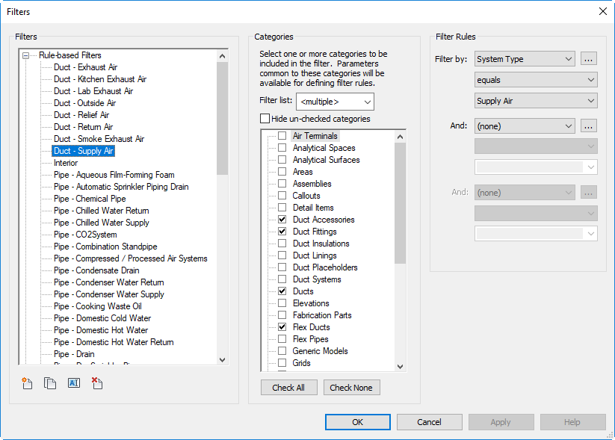

Figure 5.2‑1 Mechanical System Colors - View Filter Setup

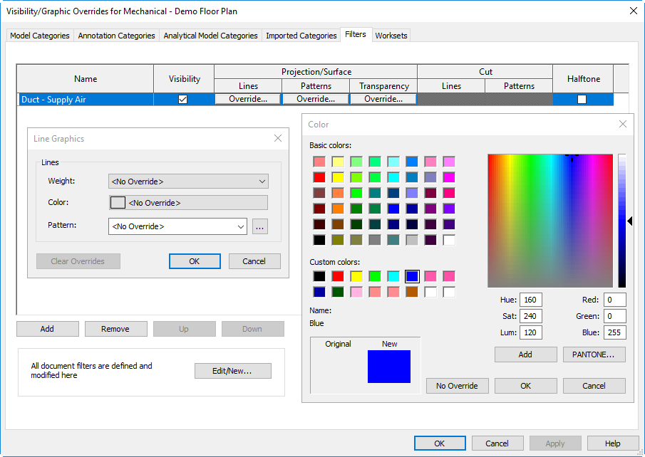

Figure 5.2‑2 Visibility/Graphic Overrides

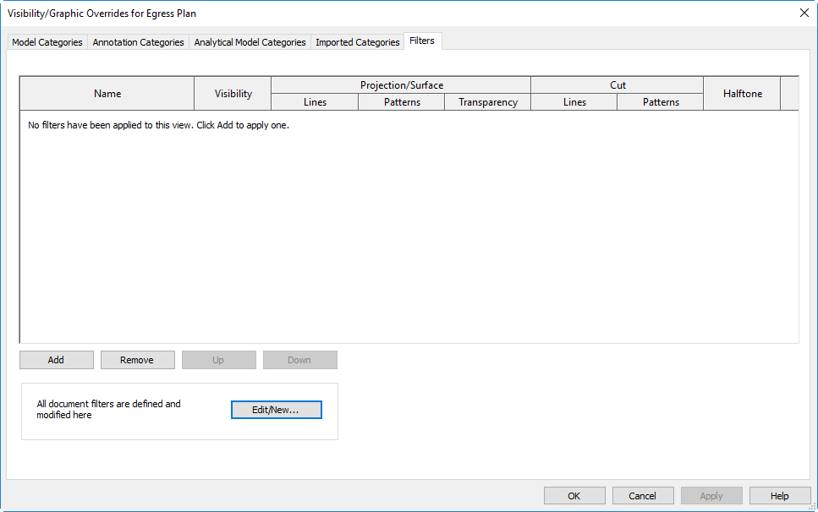

Figure 5.2‑3 Mechanical System Colors – View Filter Visibility Override

The View Filter process only applies mechanical system colors to a specific view and does not affect other discipline models or other views within the mechanical model. Applying mechanical system View Filters to specific working views or sheet views should be done as part of a View Template. Applying filters to individual sheets is a time-consuming process that is not necessary when using View Templates to establish visibility settings.